array based-list collection 数组型数据集合
P254
List Linked List

优 Because having index gives Constant time to Insert/remove element
Constant searching time=O(1) Insert/remove time=O(1)

劣 remove or add new element into list will Searching time goes one elements by one
affect other elements in the list to shift forward elements , so searching time proportional
or back ward this gives to length n
Insert/remove timing proportional to list length n time=O(n)
Insert/remove time=O(n)

listIterator method 数组型专属方法.listIterator( )数组遍历器
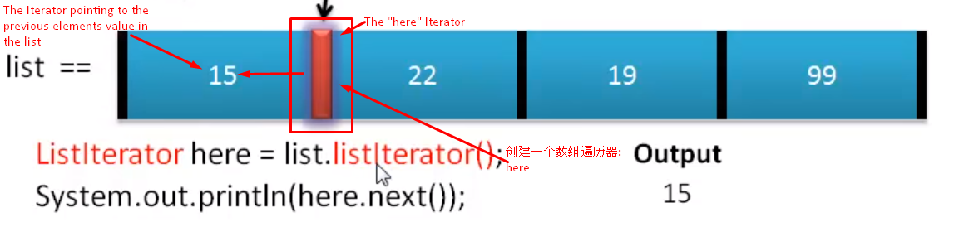

Clone method
Object object1=object.clone( ) //根据object的信息，生成一个新的object1 which have the same value of object
.clone( ) 和 new 操作的比较：
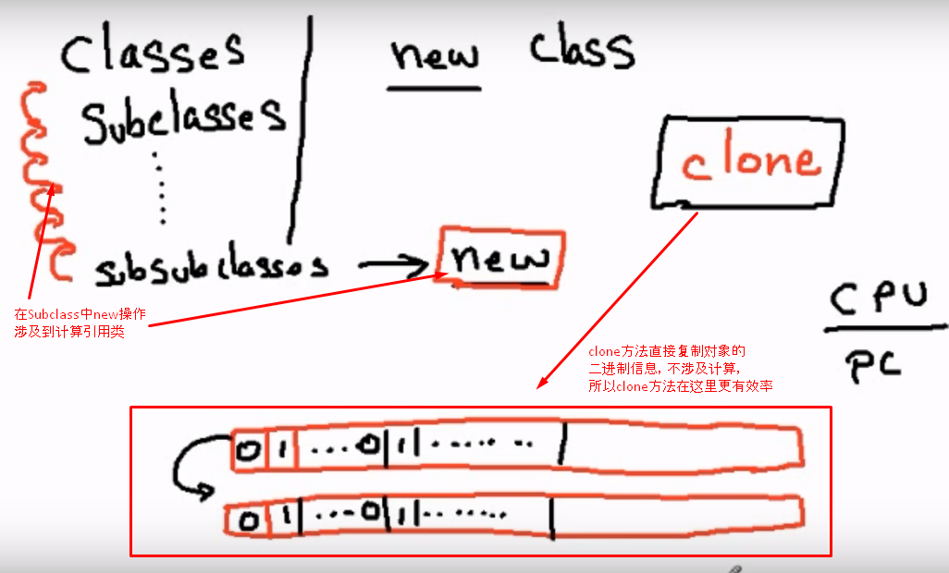

Shallow vs Deep Copy
Shallow copy :
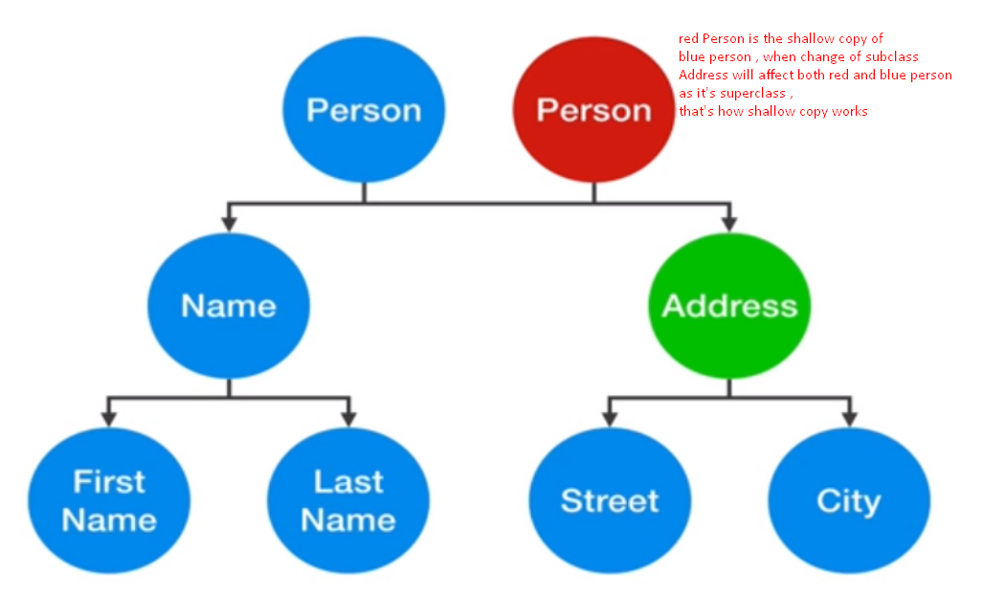
Deep copy :
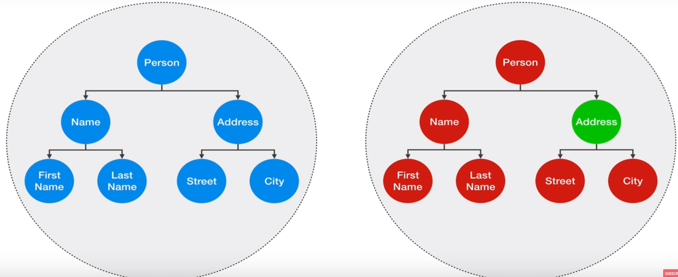
Combination shallow and deep copy :
